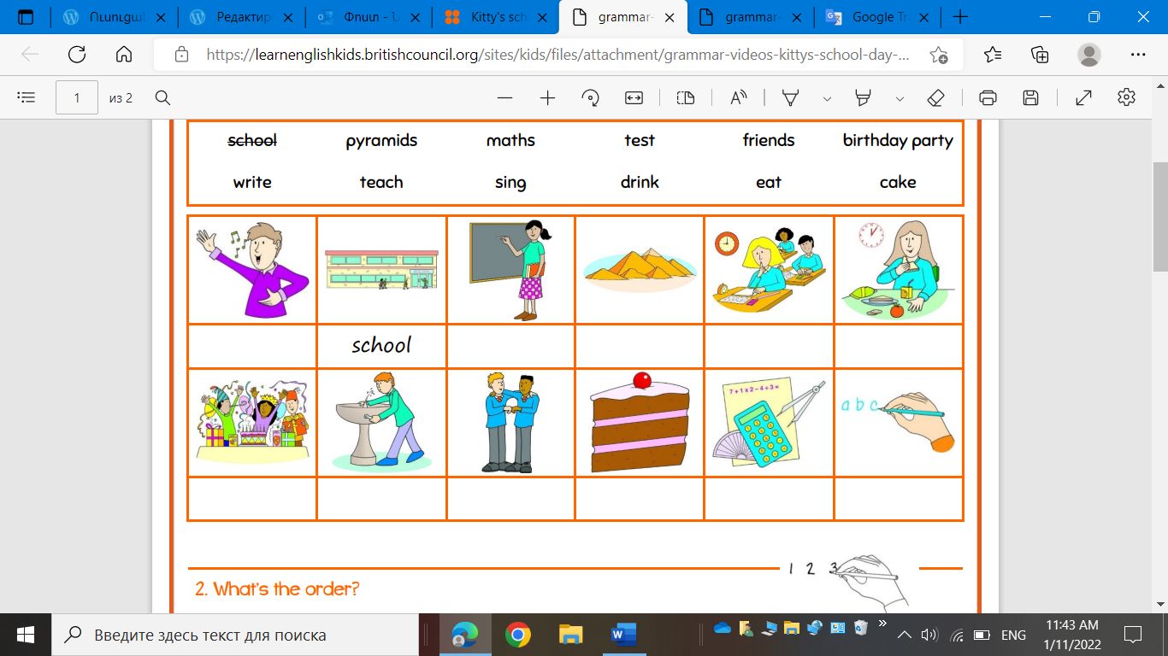
Sing
teach
pyramids
test
eat
birthday party
drink
friend
cake
math
write
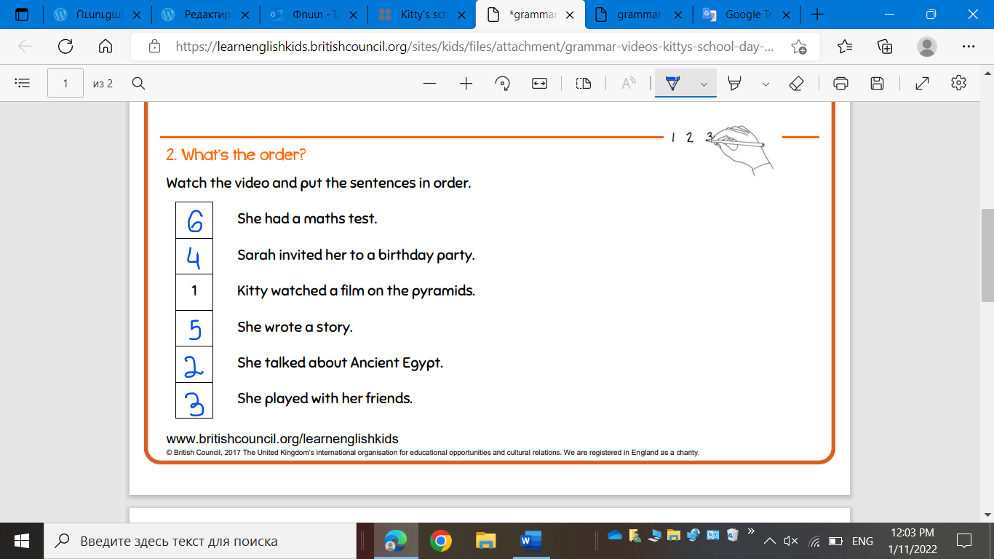

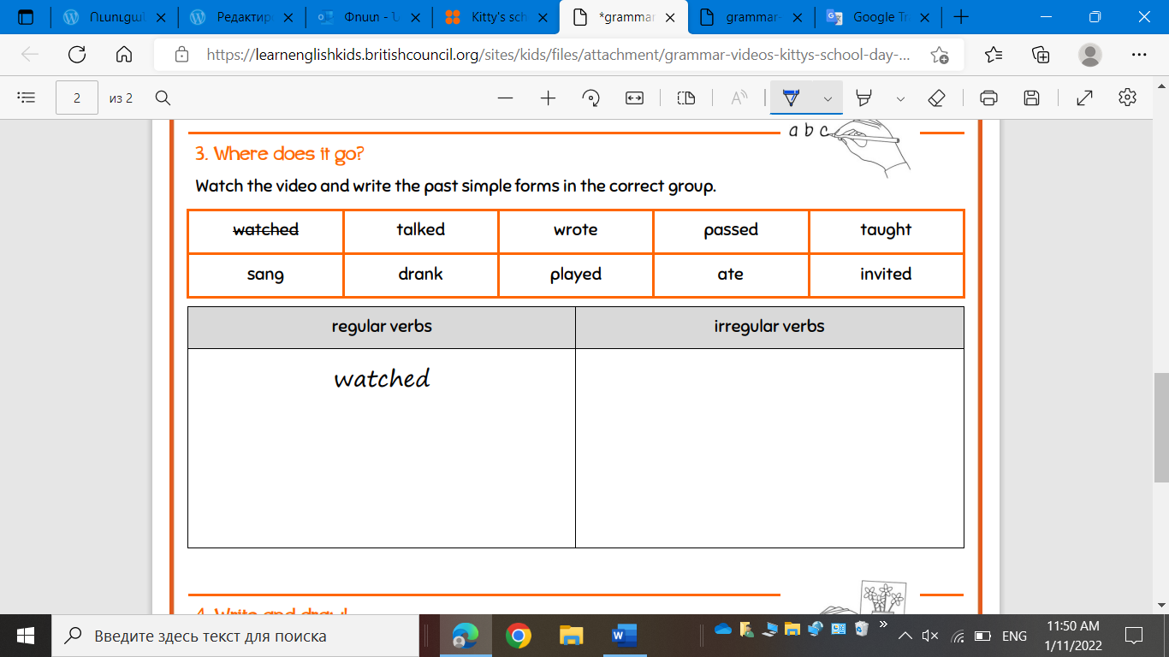

Regular verbs
Talked
Passed
Played
Invited
Irregular verbs
Wrote
Taught
Sang
Drank
Ate

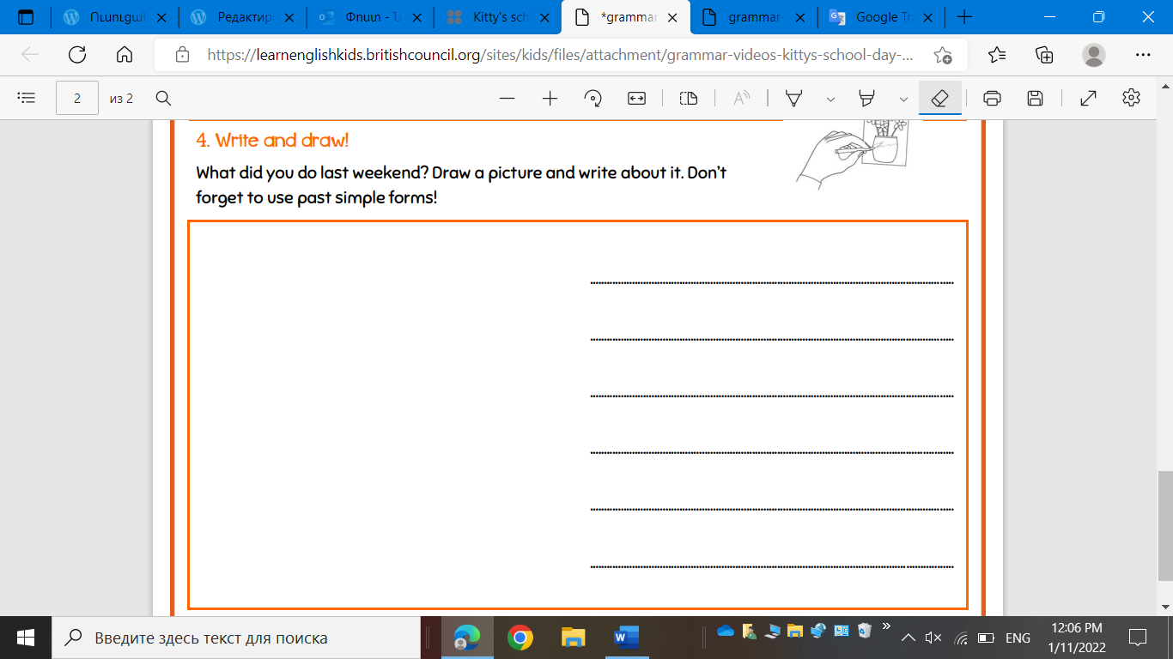
I went to the party last night.
I learnt my homework last yesterday.
She didn’t go to the zoo park last month.
They did homework yesterday.

